Alvin Tran

CSE 220-50

Assignment 1

Turn In date: 5/23/2021

**Problem 1**

The purpose of this program is to demonstrate the ability to use the **String** data type and output functions in Java. The program is expected to output whatever is within the **String** created, which represent my Name, Birthday, Hobbies, Favorite Book, and Favorite Movie.

The program simply utilizes the **System.out.println()** function in conjunction with **String** inputs to the function to provide information, which is inputted in creation of the program.

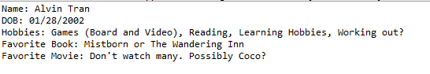

**Sample Output**

**Problem 2**

The purpose of this program is to be able to utilize the **System.out.prinln()** function and created art utilizes a series of said function and proper spacing. The expected output is my initials in block form, with each initial being represented by itself (letter).

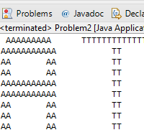

**Sample Output**

**Problem 3**

The program reads in variables defined by the programmer, and outputs the equivalent time in seconds. The program utilizes integer variables, integer math, order of operation, and string concatenation to created.

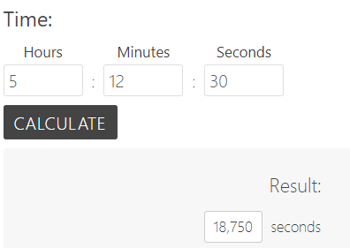

**Expected Output from Online Calculator**



**Matching Output from Program**

**Problem 4**

This program requires an input from the user representing a side length of a square as a double. The perimeter and area are then calculated and outputted. This program uses the **Scanner** class to obtain inputs from the user, uses **System.out** to output the appropriate answer to area and perimeter using string concatenation.

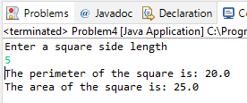

**Sample Output**

**Problem 5**

This program obtains inputs from the user for a numerator and denominator as **integers** and outputs a decimal that is equivalent to the fraction. This program needs **type casting** since the numerator an denominator are **Doubles** and dividing by 2 integers result in an integer, without decimals. The program utilizes the **Scanner** class and uses **type casting (Double)** to do the appropriate math type to not lose the decimal.

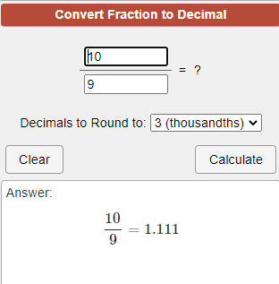

**Expected Output from Online Calculator**

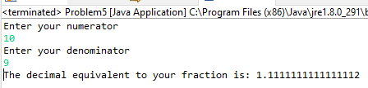

**Matching Sample Output**